Design a Network
By
Joseph Tierney

Class: Computer Science 2

Tutor: Tony Bernes

Contents

Introduction………………………………………………………..3

Company Requirements…………………………………………..4

Floor Plan………………………………………………………...5

Computer Specification…………………………………………7

Installation and Configuration………………………………….9

Administration…………………………………………………..12

Training………………………………………………………..13

Conclusion………………………………………………………..14

Bibliography………………………………………………………..15

Introduction

Windows of Opportunity is a web development company that specialize in designing and creating the best websites in the world, and possibly the galaxy. The company was founded by William Fence on April 1st, 2010. The headquarters is located in Dublin City Centre. Its main offices are located in Stephen’s Green. It currently employs twelve workers – these include the manager of the company, a sales representative, two marketing executives and eight web developers.

My company, JT Inc. has been tasked to plan a cost effective network solution, this will include details of available budget to finance this project. This report will talk about the company requirements, floor plan and logical plan, computer specification, installation and configuration, administration and training.

Company Requirements

Windows of Opportunity has asked for an upgraded network for their office in Stephen’s Green. They’ve been using their third network, which was put in in 2010 and hasn’t been updated since. Windows of Opportunity would like a new and improved network for improved work quality among staff and managers, as well as the opportunity for more profits to be made within the web development sector. Improved efficiency, which will help sharing files among workers and communication between colleagues – is another reason Windows of Opportunity wants a new network put into their offices.

There are eight people working as web developers who require access to Microsoft Office applications, printing facilities and website development software.

There are two marketing executives and a sales representative that need access to Microsoft Office applications, printing facilities, e-mail and the internet as well as website development software.

The manager of the company requires access to Microsoft Office applications, printing facilities, e-mail, and the internet and website development software.

The company already has a digital photocopier and a scanner already in the building.

Extra facilities needed in the company include servers, hubs, cables and routers – all of which will be included in the €60,000 budget set by Windows of Opportunity.

Each member in the company requires the same software, and as such, will all require the same hardware for each machine.

Floor Plan

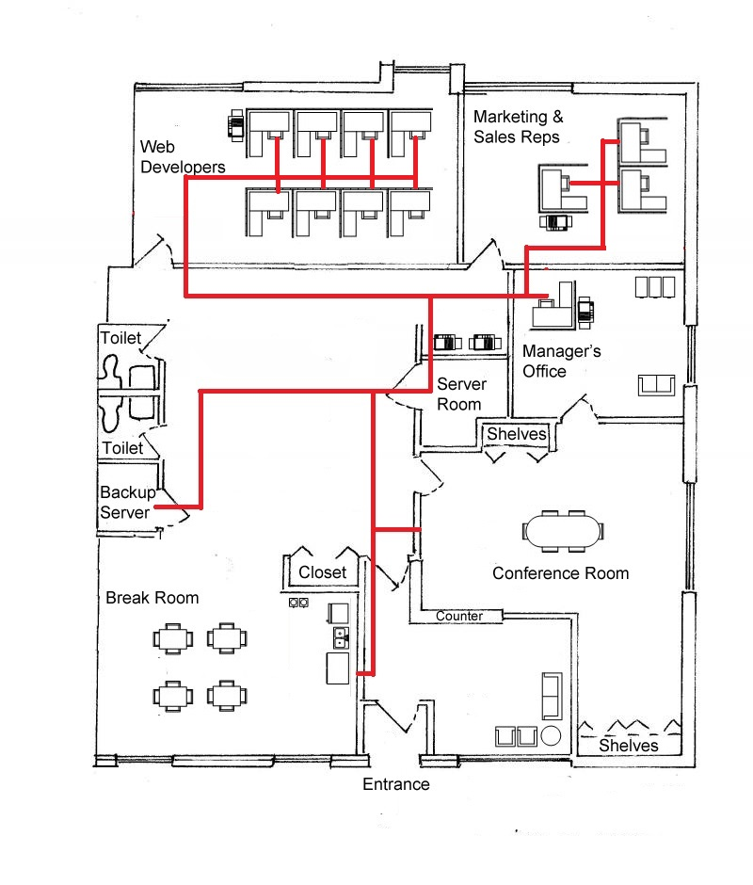

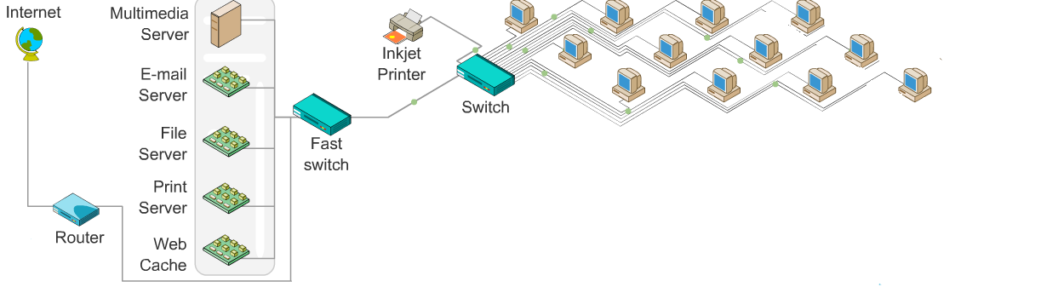

Computer Specification

Every employee in the company will use the XPS 8900 Desktop. This desktop comes with a 6th Generation Intel Core i7-6700 processor with an 8M Cache and up to 4.0 GHz. It initially comes with 16GB of RAM and a 2TB hard drive. Each desktop will have a 12 month subscription to McAfee Live Safe XPS. The video card included in this desktop is a NVIDIA GeForce GTX 745 4GB DDR, and there’s an integrated sound card. Keyboard and mouse are included with the desktop as well as hardware support for up to one year.

The operating system that will be used is Windows 10, as this is what the desktop comes with pre-installed. The option to switch to Linux is there, but as most of the users are familiar with Windows, this was the best option. As everyone in the company requires access to Microsoft Office applications, each desktop will come with Microsoft Office Professional 2016, this includes Word, Excel, One Note, Power Point, Outlook (email), Access and Publisher – this is included in the price. The internet browser that will be pre-installed on the machines will be Microsoft Edge. Google Chrome and Mozilla Firefox will also be installed once the machines have been booted up. Every desktop will have McAfee Antivirus protection. The eight web developer’s machines will have access to Adobe Dreamweaver, Photoshop and Notepad ++.

In the two server rooms (main and backup), there will be the PowerEdge T320 Tower Server. This will help boost office efficiency, with matching enterprise-class features with a dense memory footprint that enables the company to easily address core business applications quickly and efficiently. The server has up to 16 hot-swap drives as well as hardware and software RAID options to help maximize data management and its protection. There is 192GB RAM (6 DIMM slots), 32 TB internal storage, 2.5MB cache per core, core options include: 2, 4, 6, 8, 10. The processor for the server is an Intel Xeon processor and Intel Pentium processor. The operating system that comes with the server is Microsoft Windows Server 2012. The PowerEdge T320 Tower Server will be placed in a 12u CSS Server Cabinet.

The network switch that the company will be using is the Dell Networking N1500 Series. The N1500 switch series offers a power-efficient Gigabit Ethernet network-access switching solution with integrated 10GbE uplinks. It has high-performance capabilities and wire-speed performance, utilizing a non-blocking architecture to handle unexpected traffic loads easily. These switches offer simple management and scalability via a 40Gbps, full duplex high-availability stacking that allows management of up to four switches from a single IP address. Cisco ASR 1013 will be the router that the company is using, and everything will be connected with CAT 5 cables. The company will be getting two 100 meter rolls of CAT 5 cables, as this is the best investment choice, keeping future expansions possible.

The company has funding for one big network laser printer and a colour printer. The laser printer that I have chosen to go with is the Dell Smart Multifunction Printer S2815dn. This printer allows you to print documents from, and scan files directly to SharePoint On Premise without a PC. It can convert scans into searchable PDFs that are easy to share. Printing large files is hassle-free, as it has a built-in 1GB memory. The colour printer will be the HP Envy 5644, which is an all-in-one printer, but will not be on the scale of the network printer.

Installation and Configuration

CAT5 cables will run under the floor throughout the entire office, starting from the main server room and connecting to the various offices. Wireless connections will be available in the building.

For setting up the server, firstly insert the Windows Server 2012 disc into the computer and switch on the server. When prompted, press any key to boot from the disc. The files will start loading and the next screen will show the Language dialogue box. Select the correct language, currency and time options as well as the keyboard region. When this is done, a prompt to Install Now will appear. Once this is clicked, click on the check box to accept the licence terms and click next.

On the next screen you are asked to choose what type of install you want. Select Custom: Install Windows only. This is chosen because it is a fresh install. When asked, install the Operating System on the primary partition. Windows will begin installing onto the server. Once it’s completed, provide an administrator password for the new installation and click next. Once the password has been set, login by pressing Ctrl Alt Delete at the same time.

Open Server Manager by clicking start and selecting it at the top. In the next window, click Configure tis local server, this will allow the company to set up the various features they will require for the network. In here, it will allow them to change the server to name to whatever they desire.

To set the static IP address, default gateway and domain system, click on Ethernet and the Network Connection windows will open. Double click on the adaptor you wish to change IP addresses to bring up the information page. Then click on Properties and double-click on Internet Protocol version 4. Then type in all the IP address information.

Lastly, in Server Manager, active the server by clicking on the option to do so and then enter the product key that came with the software. To add a user, search for dcpromo and set up a new forest. Once this is done setting up, and you have named your domain to the desired name, go to server manager, expand roles, expand active directory, expand active directory users and expand the name of the domain and select Users. From there, right click and simply select “New User”. Enter the users information and click next. When this is done, you can create an organisational unit, and create the necessary groups within that unit.

To set up Firewalls, simply click start and search for windows firewall, and select Windows Firewall with Advanced Security. Select inbound rule, and click New Rule on the right sidebar. On the next window, select Port. Click next, and select TCP. In specific local ports type in 80, then click next and select Allow the connection. Click next and leave Domain, Private and Public checked, click next and enter the name Apache HTTP and click Finish. To install the antivirus software, simply put the disc that came with the software into the DVD/CD drive and follow the on screen instructions.

To install the operating systems on the computers, firstly, insert the installation disc into the optical drive, and reboot the computer. Press F12 to get to the BIOS. Once there, navigate to the boot section and set the DVD/CD drive as the first boot device. Save changes and exit setup for the computer to reboot. Wait for the setup program to load – this copies windows files to the computer and can take several minutes. You will also be asked to choose some basic options like language and keyboard layout.
When this is finished, you will be prompted to enter your product key, and then asked to choose an installation type (custom advanced).

Next is formatting partitions. Select which hard drive partition to install on. Deleting partitions will wipe the data on the partition and return the space to the unallocated section. Select the unallocated space and create a new partition. Wait for the installation to complete, and then create a windows login.

To add the users to the domain, simply go to System Properties and select change computer name. In the computer name text box, enter the desired name of the computer. In the member of section, click the Domain button and enter the name of the domain. Click ok and enter a username and password for a user who has the permissions to let a computer join a domain. After entering the information, click OK and if the right information has been entered, you should receive a welcome message. Once you click OK, restart the computer and log in.

To install Microsoft Office, insert the disc that came with the software into the DVD/CD drive. The setup program for Microsoft Office should start automatically once the disc is inserted, if it doesn’t, open the disc from My Computer and run setup.exe. Then enter the product key, this can be found on the disc packaging. Follow the prompts in the installer, this will allow you to choose which products you want to install. Click close when finished to finish the installation. To activate office, simply select “I want to activate over the internet” and click Next. This will activate your copy of Office online, allowing you to use all the features.

To install Dreamweaver, insert the Dreamweaver CD into the DVD/CD drive. The installer should auto-run. If it doesn’t, go to the DVD/CD drive in Windows explorer and double click on the autorun file. Enter the required information, including any registration codes required. These are the same steps for installing Photoshop.

The topology that is being used is the Star Topology. The reason for this is that a star topology is easily expanded without disruption to other network users, and when a cable fails or breaks, it only affects the user connected by that cable. Troubleshooting is easy and problems isolated to the affected user.

To add the printer, go to device manager, printers and faxes, right click and add new printer.

To install the email server, go to manager your server and click on add or remove roles. This will start the Configure your server wizard, click next. Select the Mail Server and click next. In the email domain text box, enter in the name of the domain, eg. WindowsOpp. Click Next and Finish when it’s done installing. To configure the email server, click start and type in “server.msc” in the search bar. Click on the name of the computer, and click on server properties in the right pane. Follow the on screen instructions.

Administration

There will be four different groups for the server. The first group will be Admins, which the manager will be the only member of. The second group will be for Web Developers only, the third will be for the Sales and Marketing and the fourth and final group will be Sales and Marketing w/ Manager, which will have the three sales and marketing workers alongside the manager, as they need to work closely together and possibly share files.

Each user will be part of the domain WindowsOpp. Each worker has the same password, excluding the manager. Every password will simply be Password1. The manager will be required to change his or her password when they first login. The reason behind the manager having their own exclusive password is for the companies security, as they are in charge of everything and have access to all resources and files, as well as server administration.

The manager has access to everything, this includes managing printers, deleting printers, managing users, deleting users, changing user passwords if necessary, they also have access to all files within the company. Every other worker has access to the printer, but they can’t manage or delete printers. Everyone has access to the internet, however, certain websites like facebook and twitter have been blocked during non-lunch hours – this was done to increase productivity and efficiency. Everyone has access to email and the all Microsoft Office applications.

Training

Dell offer training on managing and updating servers. This costs roughly €3,432.30, or €179 euro a month and takes place three days a week over the course of 20 months. The training can be provided to the entire company for the one price. The manager will be appointed to administer the network when the job has been completed.

Conclusion

Windows of Opportunity asked for a new and improved computer system for their company, one that is within their budget and leaves room for possible expansions. I believe that this is the best possible network for the company – the remaining budget leaves room for future expansions with the possibility of hiring more employees, they will have more than enough to cover the cost of a desktop and a monitor. With the left over cables, it will be easy to add more computers to the company. A recommendation that I would provide them is to back-up their data regularly and do not be afraid to upgrade the equipment as technology needs advance.

Receipt
Budget | €60,000
Desktops (12) [€1,417.21] | €17,006.52
Monitor (12) [€116.22] | €1,394.64
Servers (2) [€1,416.00] | €2,832
Ethernet Cable Rolls (2) [€14.21] | €28.42
Router | €2,377
Switches (2) [€827.00] | €1,654
Server Rack (2) [€596.70] | €1,193.40
Laser Printer | €422.89
Colour Printer | €99.99
Training | €3,432.30
Adobe Photoshop | €395
Adobe Dreamweaver | €395
Total | €31,231.16
Remaining Budget | €28,768.84

Bibliography

Configure.euro.dell.com. (2016). The Dell Online Store: Build Your System. [online] Available at: http://configure.euro.dell.com/dellstore/config.aspx?oc=bdx8924&model_id=xps-8900-desktop&c=ie&l=en&s=bsd&cs=iebsdt1 [Accessed 18 Mar. 2016].

Server, P. (2016). PowerEdge T320 Tower Server. [online] Dell. Available at: http://www.dell.com/ie/business/p/poweredge-t320/pd [Accessed 18 Mar. 2016].

Configure.euro.dell.com. (2016). The Dell Online Store: Build Your System. [online] Available at: http://configure.euro.dell.com/dellstore/config.aspx?c=ie&cs=iebsdt1&kc=305&l=en&oc=E2016&s=bsd&sbc=dell-e2016-monitor [Accessed 18 Mar. 2016].

Switches, D. (2016). Dell Networking N1500 Series Switches. [online] Dell. Available at: http://www.dell.com/ie/business/p/networking-n1500-series/pd [Accessed 20 Mar. 2016].

Cabinet, 1. (2016). 12u 600mm(w) x 1000mm(d) CCS Server Cabinet. [online] Cablemonkey.ie. Available at: http://www.cablemonkey.ie/600mm-x-1000mm-ccs-server-cabinets-racks/175-12u-600mmw-x-1000mmd-ccs-server-cabinet.html#/doors-meshfrontrear/sidepanels-withsides/castors-transitcastors/rooffans-2wayfanunit [Accessed 20 Mar. 2016].

Cisco. (2016). Cisco ASR 1013 Router. [online] Available at: http://www.cisco.com/c/en/us/products/routers/asr-1013-router/index.html [Accessed 21 Mar. 2016].

Freetv.ie. (2016). 100m Ethernet Cables - Buy Best Priced Ethernet Cable Online. [online] Available at: http://www.freetv.ie/100m-ethernet-cable.html [Accessed 21 Mar. 2016].

Configure.euro.dell.com. (2016). The Dell Online Store: Build Your System. [online] Available at: http://configure.euro.dell.com/dellstore/config.aspx?c=ie&cs=iedhs1&kc=305&l=en&oc=S2815DN&s=dhs&sbc=dell-s2815dn-printer [Accessed 21 Mar. 2016].

http://www.buy4now.com, B. (2016). HP ENVY 5644 All-in-One Inkjet Printer | Our Easter Mega Deals |. [online] Pcworld.ie. Available at: http://www.pcworld.ie/Product/hp-envy-5644-allinone-inkjet-printer/324636/408.0 [Accessed 21 Mar. 2016].

Shop.adobe.com. (2016). Adobe Store - Most Popular. [online] Available at: http://shop.adobe.com/ [Accessed 22 Mar. 2016].

